How to create and use an SQLite database?

**Orion**

LinkBird Technologies

http://www.codecanyon.net/user/linkbirdtech

Orion



**This lesson will show how quickly and easily you can set up and start using an SQLite database using DB Browser.**

**Step 1**

Please download & install DB Browser

<http://sqlitebrowser.org/>

**Step 2**

Follow how to create SQLite database using DB Browser

* Open DB Browser
* Click New Database button

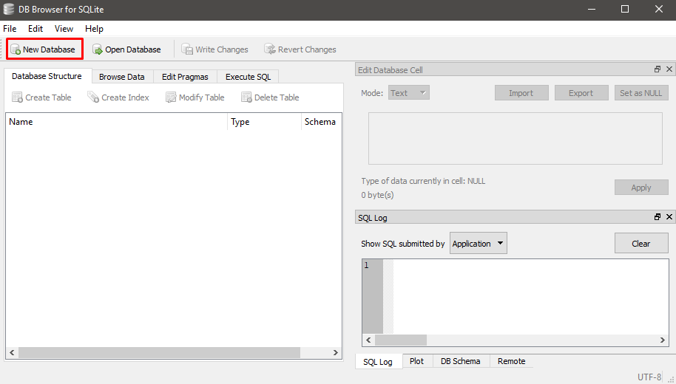

* Choose a filename and location
* Click on Save Button

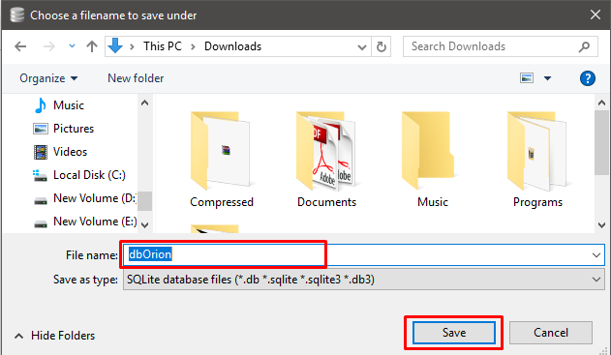

Now you can Create, Modify & Delete datatable

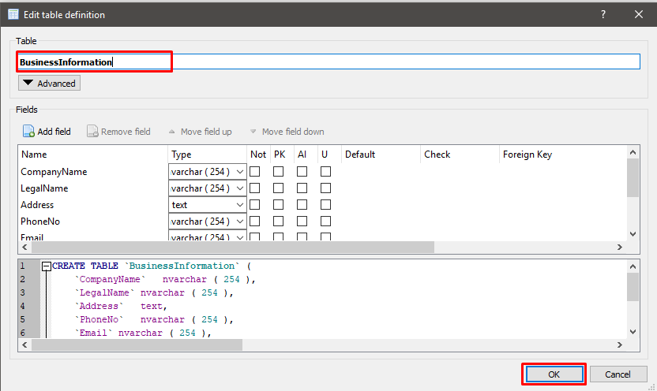

You can create a new data table

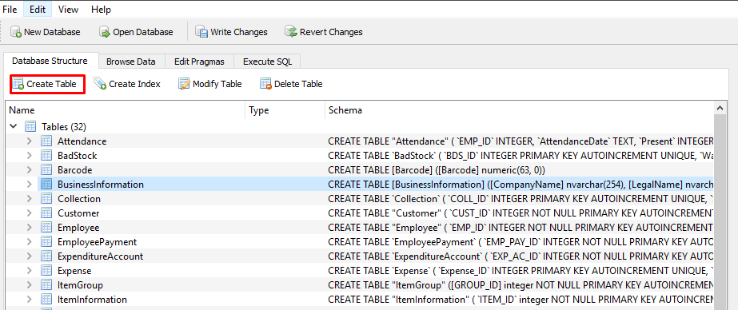

After making any change, Pease click on Write Changes button

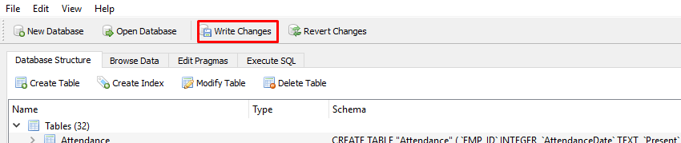

**Step 3**

Connecting to the database

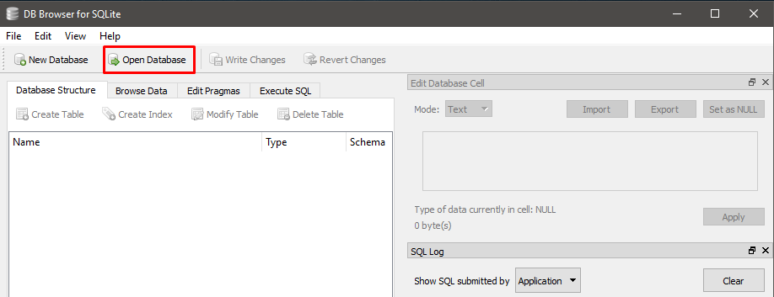

Browse database and click open button

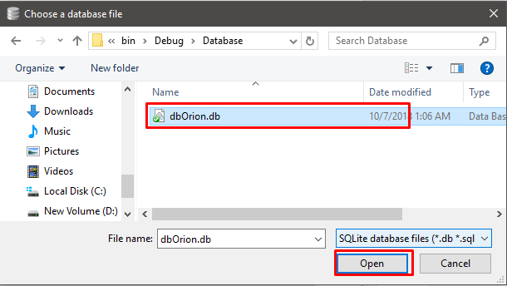

All tables on the database are displayed.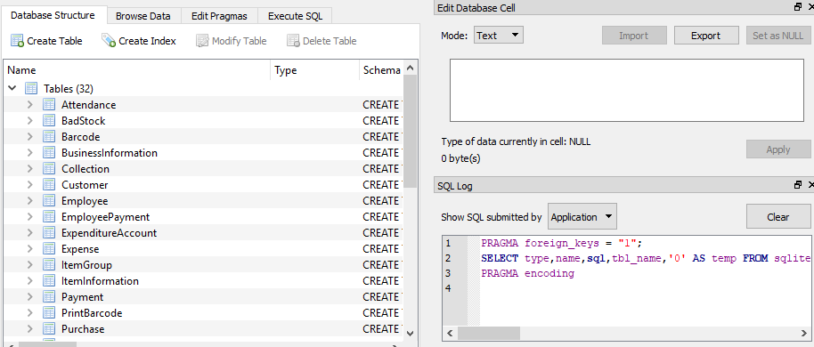

You can Browse, Modify, Delete, Create from here

